**Demo: Pushing a File to the GitHub Repository**

**Objective:** To demonstrate the process of pushing a file to a GitHub repository using Git commands for version control and collaboration

**Tools required:** Git and GitHub

**Prerequisites:** You need to have Git installed to proceed with this demo.

**Steps to be followed:**

1. **Create a GitHub repository**
2. **Create a repository on the local machine**
3. **Push the changes in the local repository to GitHub**
4. **Check the status of the local and remote repository**

**Step 1: Create a GitHub repository**

**1.1** Open the browser in your lab, go to github.com, and log in to your account



**Note:** If you do not have a GitHub account, visit the official website at https://github.com/signup and create a new account

**1.2** Click on the **New button** to create a **new GitHub repository**

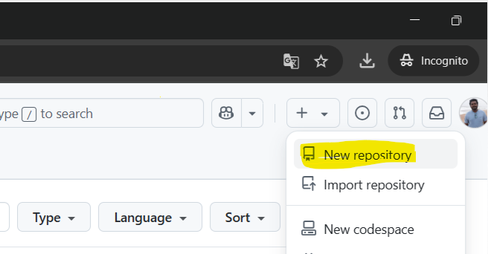

**1.3** Enter the repository name and description, then click the **Create repository button**

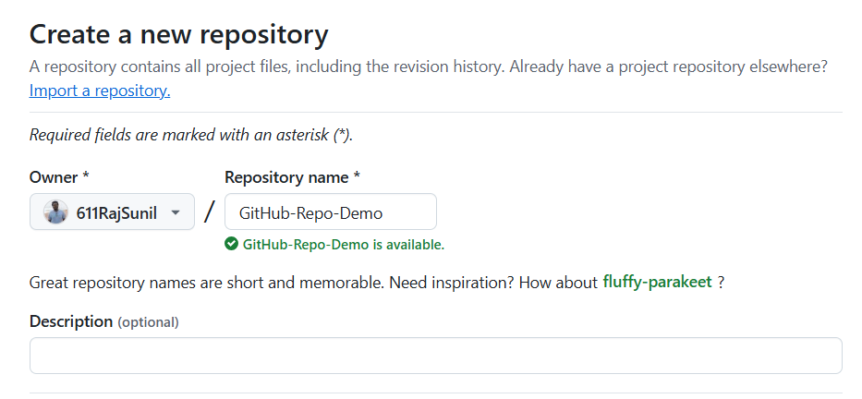

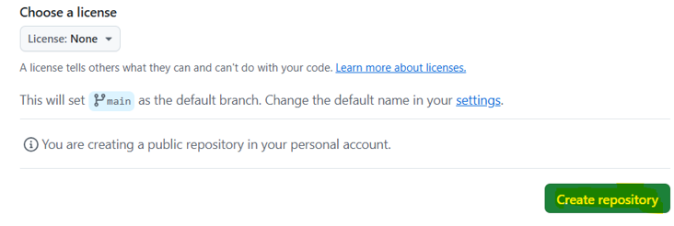

**Step 2: Create a repository on the local machine**

**2.1** Open the terminal tab in your lab, and execute the following command to create a new project directory: **mkdir createnewproject**



**2.2** Run the following command to change the directory: **cd createnewproject**



**2.3** Create a Hello.txt file using the following command: **echo "# create new file for my project" >> Hello.txt**





**2.4** Initialize the Git repository using the following command: **git init**



**2.5** Add the Hello.txt file using the command given below: **git add .**

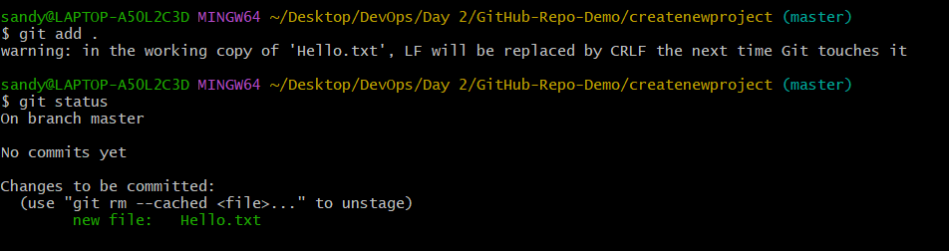

**2.6** Use the following command to commit the changes: **git commit -m "Added Hello.txt file"**

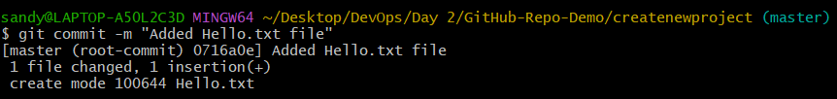

**Step 3: Push the changes in the local repository to GitHub**

**3.1** Open the Terminal and add a remote repository using the following command: **git remote add origin <URL>**



**Note:** While creating the remote repository, copy the HTTPS URL

**3.2** Push the changes to the remote repository using the following command: **git push -u origin master**

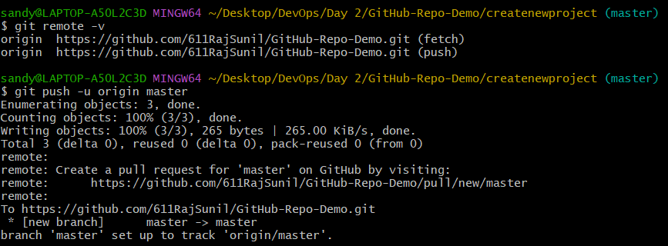

**Note:** After executing the Git push command, you will be asked to enter the username and password for your GitHub account.

**Step 4: Check the status of the local and remote repository**

**4.1** Run the following command to check the status of the local repository: **git status**

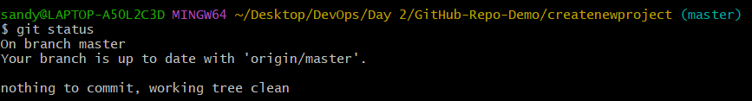

**4.2** Visit **github.com** to inspect the remote repository

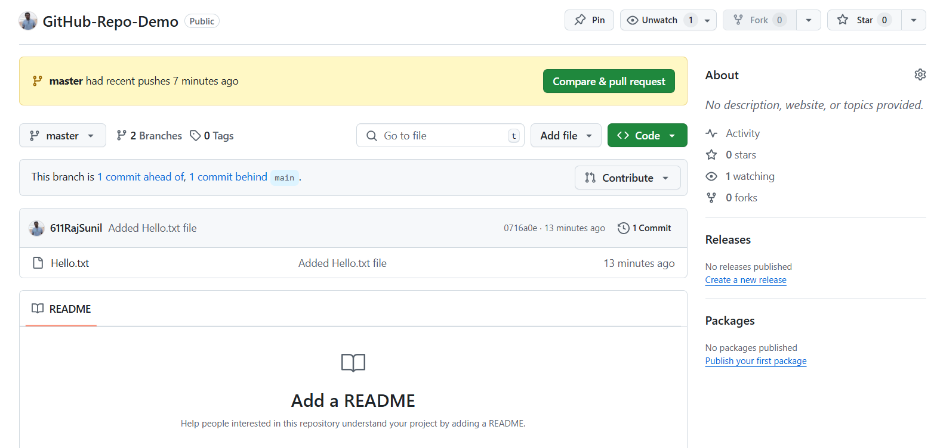

By following these steps, you've effectively demonstrated the process of pushing a file to a GitHub repository using Git commands for version control and collaboration.

